**Instructions for Installing MySQL Server / MySQL Workbench and Connecting to Relational Dataset Repository**

**Overview**

This document covers how to download and install MySQL Server and Workbench as well as how to connect to the Relational Dataset Repository that will provide the data used in demos, labs, and assignments for this course.

1. **Install MySQL Workbench Community Edition and MySQL Server**

**Overview:** MySQL (Server) is an open source relational database management system (RDBMS) developed by Oracle. MySQL Workbench is the integrated environment for MySQL and via a GUI enables users to administer, design and query databases. We will be using MySQL Workbench as the primary querying tool for this course.

**Installation Instructions for Windows**

[Follow this link](https://www.youtube.com/watch?v=u96rVINbAUI) for video follow along instructions to install MySQL Workbench and MySQL Server using Windows.

**Installation Instructions for Mac OS**

[Follow this link](https://www.youtube.com/watch?v=WTCrqRBUDT0) for video follow along instructions to install MySQL Workbench and MySQL Server using Mac OS.

Continue to page 2 for instructions on connection to relational dataset repository…

1. **Connect to Relational Dataset Repository**

**Overview**: This repository has dozens of relational data sets that mirror the structure and design of an actual database. Additional information on the repository can be found [here](https://relational-data.org/).

1. Once you have successfully installed MySQL Server and MySQL Workbench navigate to the Workbench home page. 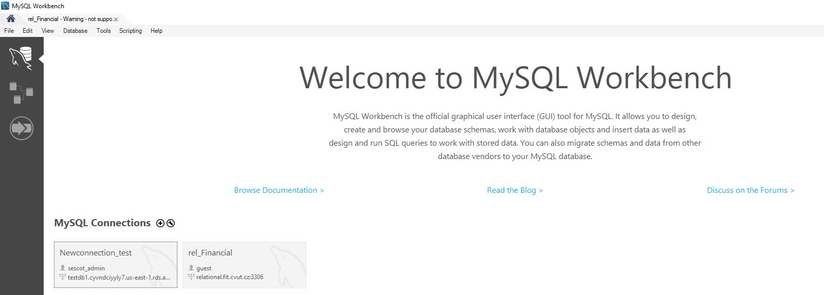
2. Navigate to the ‘MySQL Connections’ section and select the plus sign 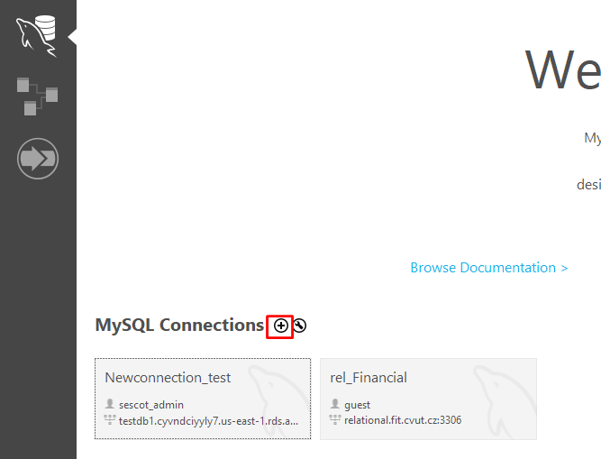
3. The resulting pop up will look something like: 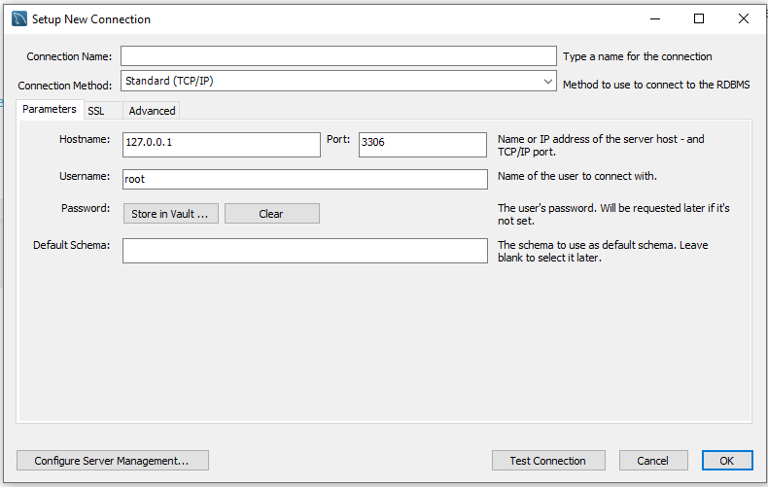
4. Fill the hostname, port, username, and password fields with the below values. Also, be sure to name your connection in the ‘Connection Name’ field. Any name will do!

1. Once you have entered in your credentials select ‘Test Connection’ (if up to this point you have not entered in a password you will be prompted to now). A screenshot of a computer

   Description automatically generated
2. If a Connection Warning pop up appears, select ‘Continue Anyway’.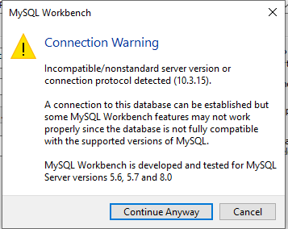
3. You should now get a pop up that says ‘Successfully made the MySQL Connection’. Hooray!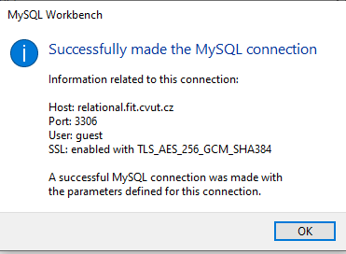

**I will go through the basics of how to use MySQL Workbench in class but if you feel like getting a head start check out this** [**tutorial**](https://www.youtube.com/watch?v=chezeWdTHbo)**!**